18001
PRACTICAL NO : 01
Study of Networking Device

Q1. Identify the network address & subnet mask for the ip address 192.168.1.0
Given ip address is 192.168.1.0
The subnet mask is 255.255.255.0 as it is belong to class C
In Binary Form:-
11111111 .11111111 .11111111.00000000 In this the 1st 24 bits represent the host part.

Q2. Create 4 Subnets:-
To create 4 subnets we need to binary two bits from the host part.
2^2=4
So the new subnet mask is 255.255.255.192
Binary Form:-
11111111.11111111.11111111.11000000
so 26 bits for the network part 6 bits for the host part. Total no. of subnet 4.
[ combining 2 or more subnets will give us the Supernet.]
Total no. Of useable ip address in each subnet is 64- -2 because 1 address is for network
and 1 for broadcast, so subtracting them. 62 IP addresses are usable.
CIDR format:-classless InterDomain Representation.
New Subnet Mask:- 255.255.255.192/126
The 1st subnet mask is 192.168.1.0/126
The 2nd subnet mask is 192.168.1.64/126
Subnet 1=192.168.1.0 ---> Network address
Useable host address 192.168.1.62/126
Broadcast address 192.168.1.63/26
Subnet 2 192.168.1.64
1st host address 192.168.1.65
Last host address 192.168.1.126/26
Broadcast address 192.168.1.127
Subnet 3 192.168.1.128
Last address is 192.168.1.190

PAYAL AMALE S.I.W.S. College Major practical 01
18001
15th address is 192.168.1.129
Subnet 4 192.168.1.192
Last address is 192.168.1.254
Broadcast address 192.168.1.255

Q3. A network address 192.168.1.0/24 creates 3 subnets with subnet 1 corrosting if so
subnet 2 with 20, and subnet 3 with 10.
(Since the no. The host bit is determined by the ip address. So ip address formula to
calculate no. Of bits required to satisfy each subnet ip address is 2^n/ no. of ip address
required.
Where n is the no. of bits and +2 represent n|6)
Subnet 1 of 50 ip address
Ex:- 2^6 = 64 with 62 usable ip addresses we need 6 host bits.
Subnet mask is 255.255.255.192/26
2^5 = 32 ,30 useable
Subnet mask is 255.255.255.224|27
2^4=16
Subnet 255.255.255.140|28
Subnet 1
Subnet mask: 255.255.255.192|26
Network address 192.168.1.0|26
Host address 192.168.1.1|26
Last host address 192.168.1.50|26
Useable ip address 62//
Broadcast 192.168.1.63|26

PAYAL AMALE S.I.W.S. College Major practical 01

18001
PRACTICAL NO: 02
Demonstrate the Static Routing in Packet Tracer.

AIM :- To configure and demonstrate static routing between two networks using two routers in Packet Tracer.

STEPS :-
- In packet tracer place 2 PCs and 2 Routers.
- Connect Router0 with PC0 via FastEthernet0/0 using cross-copper cord and Router1 with PC1 via FastEthernet0/0 using cross-copper cord.
- Connect both routers via FastEthernet0/1 using cross-copper cord.
- Set the IP address and default gateway of both the PCs in IP configuration of both PCs respectively.

TOPOLOGY :-

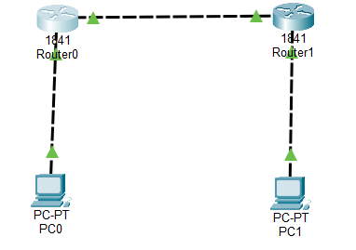

Code
Router0 configuration
Router>enable
Router#configure terminal
Router(config)#interface FastEthernet0/0
Router(config-if)#ip address 10.0.0.1 255.0.0.0
Router(config-if)#no shutdown

PAYAL AMALE S.I.W.S. College Major practical 02

18001
Router(config-if)#exit
Router(config)#interface FastEthernet0/1
Router(config-if)#ip address 20.0.0.1 255.0.0.0
Router(config-if)#no shutdown
Router(config-if)#exit
Router(config)#ip route 40.0.0.0 255.0.0.0 20.0.0.2
Router(config)#exit

Router1 configuration
Router>enable
Router#configure terminal
Router(config)#interface FastEthernet0/1
Router(config-if)#ip address 20.0.0.2 255.0.0.0
Router(config-if)#no shutdown
Router(config-if)#exit
Router(config)#interface FastEthernet0/0
Router(config-if)#ip address 40.0.0.1 255.0.0.0
Router(config-if)#no shutdown
Router(config-if)#exit
Router(config)#ip route 10.0.0.0 255.0.0.0 20.0.0.1
Router(config)#exit

PC 0 :
C:\>ipconfig
C:\>ping 10.0.0.1
C:\>ping 20.0.0.1
C:\>ping 20.0.0.2
C:\>ping 40.0.0.1
C:\>ping 40.0.0.2

PC 1:
C:\>ipconfig
C:\>ping 40.0.0.1
C:\>ping 20.0.0.2
C:\>ping 20.0.0.1

PAYAL AMALE S.I.W.S. College Major practical 02

18001
C:\>ping 10.0.0.1
C:\>ping 10.0.0.2

OUTPUT:-
PC 0:
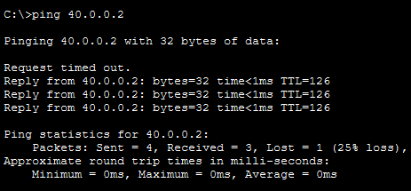

PC 1:
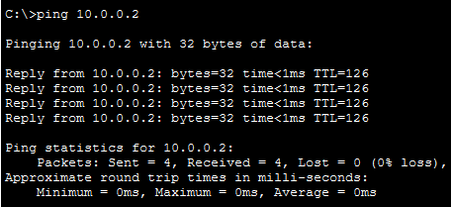

Conclusion :
The above network topology has been executed successfully and static routing has been demonstrated. Communication between PC0 (10.0.0.2) and PC1 (40.0.0.2) across two routers has been verified with successful ping results.

PAYAL AMALE S.I.W.S. College Major practical 02

18001
Q2.Demonstrate the OSPF Routing in Packet Tracer.

AIM :- To configure and demonstrate OSPF dynamic routing protocol between two networks using two routers in Packet Tracer.

STEPS :-
- In packet tracer place 2 PCs and 2 Routers.
- Connect Router0 with PC0 via FastEthernet0/0 using cross-copper cord and Router1 with PC1 via FastEthernet0/0 using cross-copper cord.
- Connect both routers via FastEthernet0/1 using cross-copper cord.
- Set the IP address and default gateway of both the PCs in IP configuration of both PCs respectively.
- Configure OSPF routing protocol on both routers.

TOPOLOGY:-
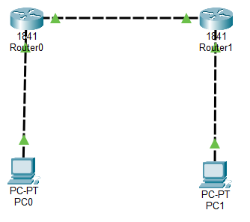

Code :
Router0 configuration :
Router>enable
Router#configure terminal
Router(config)#hostname Router0
Router0(config)#interface FastEthernet0/0
Router0(config-if)#ip address 192.168.1.1 255.255.255.0

PAYAL AMALE S.I.W.S. College Major practical 02

18001
Router0(config-if)#no shutdown
Router0(config-if)#exit
Router0(config)#interface FastEthernet0/1
Router0(config-if)#ip address 10.0.0.1 255.255.255.0
Router0(config-if)#no shutdown
Router0(config-if)#exit
Router0(config)#router ospf 1
Router0(config-router)#network 192.168.1.0 0.0.0.255 area 0
Router0(config-router)#network 10.0.0.0 0.0.0.255 area 0
Router0(config-router)#exit
Router0(config)#exit
Router0#copy running-config startup-config

Router1 configuration :
Router>enable
Router#configure terminal
Router(config)#hostname Router1
Router1(config)#interface FastEthernet0/1
Router1(config-if)#ip address 10.0.0.2 255.255.255.0
Router1(config-if)#no shutdown
Router1(config-if)#exit
Router1(config)#interface FastEthernet0/0
Router1(config-if)#ip address 172.16.1.1 255.255.255.0
Router1(config-if)#no shutdown
Router1(config-if)#exit
Router1(config)#router ospf 1
Router1(config-router)#network 10.0.0.0 0.0.0.255 area 0
Router1(config-router)#network 172.16.1.0 0.0.0.255 area 0
Router1(config-router)#exit
Router1(config)#exit
Router1#copy running-config startup-config

PAYAL AMALE S.I.W.S. College Major practical 02

18001

PC0 configuration :
- IP Address: 192.168.1.2
- Subnet Mask: 255.255.255.0
- Default Gateway: 192.168.1.1

PC1 Configuration :
- IP Address: 172.16.1.2
- Subnet Mask: 255.255.255.0
- Default Gateway: 172.16.1.1

PC0 Command Prompt :
C:\>ipconfig
C:\>ping 192.168.1.1
C:\>ping 10.0.0.1
C:\>ping 10.0.0.2
C:\>ping 172.16.1.1
C:\>ping 172.16.1.2

PC1 Command Prompt :
C:\>ipconfig
C:\>ping 172.16.1.1
C:\>ping 10.0.0.2
C:\>ping 10.0.0.1
C:\>ping 192.168.1.1
C:\>ping 192.168.1.2

Router Verification Command
Router0#show ip route
Router0#show ip ospf neighbour
Router0#show ip ospf database
Router1#show ip route
Router1#show ip ospf neighbour

PAYAL AMALE S.I.W.S. College Major practical 02

18001
OUTPUT:
PC0 OUTPUT :
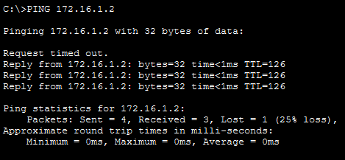

PC1 OUTPUT :
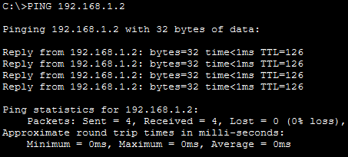

OSPF Neighbour Output:
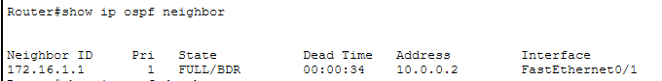

PAYAL AMALE S.I.W.S. College Major practical 02

18001
IP Route Output:

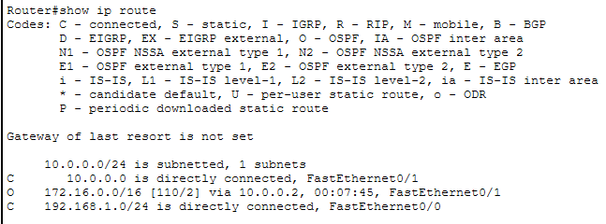

Conclusion : The above network topology has been executed successfully and OSPF dynamic routing has been demonstrated.

Q3. Demonstrate the RIP Routing in Packet Tracer.

AIM :- To configure and demonstrate RIP dynamic routing protocol between two networks using two routers in Packet Tracer.

STEPS :-
- In packet tracer place 2 PCs and 2 Routers.
- Connect Router0 with PC0 via FastEthernet0/0 using cross-copper cord and Router1 with PC1 via FastEthernet0/0 using cross-copper cord.
- Connect both routers via FastEthernet0/1 using cross-copper cord.
- Set the IP address and default gateway of both the PCs in IP configuration of both PCs respectively.
- Configure RIP version 2 routing protocol on both routers.

PAYAL AMALE S.I.W.S. College Major practical 02

18001
TOPOLOGY :-

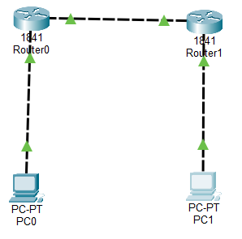

Code:
Router0 Configuration:
Router>enable
Router#configure terminal
Router(config)#hostname Router0
Router0(config)#interface FastEthernet0/0
Router0(config-if)#ip address 192.168.10.1 255.255.255.0
Router0(config-if)#no shutdown
Router0(config-if)#exit
Router0(config)#interface FastEthernet0/1
Router0(config-if)#ip address 10.10.10.1 255.255.255.0
Router0(config-if)#no shutdown
Router0(config-if)#exit
Router0(config)#router rip
Router0(config-router)#version 2
Router0(config-router)#network 192.168.10.0
Router0(config-router)#network 10.10.10.0
Router0(config-router)#no auto-summary
Router0(config-router)#exit
Router0(config)#exit
Router0#copy running-config startup-config

PAYAL AMALE S.I.W.S. College Major practical 02

18001
Router1 configuration:
Router>enable
Router#configure terminal
Router(config)#hostname Router1
Router1(config)#interface FastEthernet0/1
Router1(config-if)#ip address 10.10.10.2 255.255.255.0
Router1(config-if)#no shutdown
Router1(config-if)#exit
Router1(config)#interface FastEthernet0/0
Router1(config-if)#ip address 172.16.20.1 255.255.255.0
Router1(config-if)#no shutdown
Router1(config-if)#exit
Router1(config)#router rip
Router1(config-router)#version 2
Router1(config-router)#network 10.10.10.0
Router1(config-router)#network 172.16.20.0
Router1(config-router)#no auto-summary
Router1(config-router)#exit
Router1(config)#exit
Router1#copy running-config startup-config

PC0 Configuration:
- IP Address: 192.168.10.2
- Subnet Mask: 255.255.255.0
- Default Gateway: 192.168.10.1

PC1 Configuration:
- IP Address: 172.16.20.2
- Subnet Mask: 255.255.255.0
- Default Gateway: 172.16.20.1

PCO Command Prompt :
C:\>ipconfig
C:\>ping 192.168.10.1
C:\>ping 10.10.10.1

PAYAL AMALE S.I.W.S. College Major practical 02

18001
C:\>ping 10.10.10.2
C:\>ping 172.16.20.1
C:\>ping 172.16.20.2

PC0 Command Prompt :
C:\>ipconfig
C:\>ping 172.16.20.1
C:\>ping 10.10.10.2
C:\>ping 10.10.10.1
C:\>ping 192.168.10.1
C:\>ping 192.168.10.2

Router Verification Commands:
Router0#show ip route
Router0#show ip protocols
Router0#show ip rip database
Router1#show ip route
Router1#show ip protocols

OUTPUT :
PC0 OUTPUT :
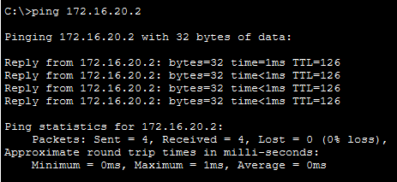

PAYAL AMALE S.I.W.S. College Major practical 02

18001

PC1 OUTPUT :
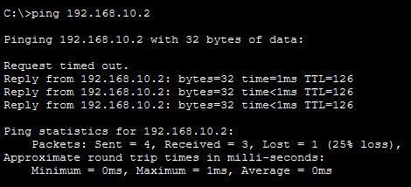

IP ROUTE OUTPUT :
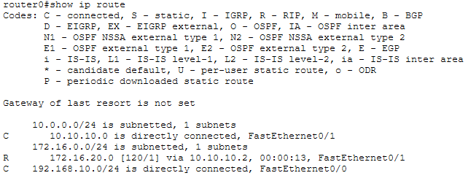

RIP PROTOCOL OUTPUT :
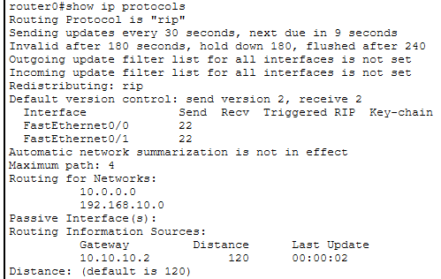

CONCLUSION : The above network topology has been executed successfully and RIP version 2 dynamic routing has been demonstrated.

PAYAL AMALE S.I.W.S. College Major practical 02
18001
PRACTICAL NO 03
Q1. Demonstrate DHCP Server in Cisco Packet Tracer.

AIM :- To configure a router as DHCP server to automatically assign IP addresses to clients.

Devices Required:
- 1 Router (1841 or any model)
- 1 Switch (2960 or any model)
- 2-4 PCs

Connections:
- Router FastEthernet0/0 to Switch FastEthernet0/1 (Straight-through cable)
- PC0 to Switch FastEthernet0/2 (Straight-through cable)
- PC1 to Switch FastEthernet0/3 (Straight-through cable)

Topology :
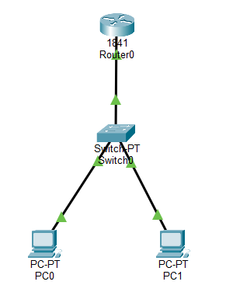

Code :
Router Configuration Commands:
Router>enable
Router#configure terminal
Router(config)#hostname DHCP-Router

PAYAL AMALE S.I.W.S. College Major practical 03

18001
DHCP-Router(config)#interface FastEthernet0/0
DHCP-Router(config-if)#ip address 10.0.0.1 255.255.255.0
DHCP-Router(config-if)#no shutdown
DHCP-Router(config-if)#exit

DHCP Pool Configuration:
DHCP-Router(config)#ip dhcp pool STUDENT_NETWORK
DHCP-Router(dhcp-config)#network 10.0.0.0 255.255.255.0
DHCP-Router(dhcp-config)#default-router 10.0.0.1
DHCP-Router(dhcp-config)#dns-server 8.8.8.8
DHCP-Router(dhcp-config)#exit

Exclude IP Addresses:
DHCP-Router(config)#ip dhcp excluded-address 10.0.0.1 10.0.0.10
DHCP-Router(config)#exit
DHCP-Router#copy running-config startup-config

PC Configuration:
- On each PC, go to Desktop tab → IP Configuration
- Select DHCP option

Verification cammand :
On Router:
DHCP-Router#show ip dhcp pool
DHCP-Router#show ip dhcp binding
DHCP-Router#show ip interface brief

On both PCs (Command Prompt):
C:\>ipconfig
C:\>ipconfig /all
C:\>ping 10.0.0.1

PAYAL AMALE S.I.W.S. College Major practical 03

18001
Output Results:
PC0 - ipconfig:
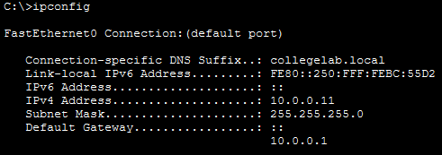

PC1 - ipconfig:
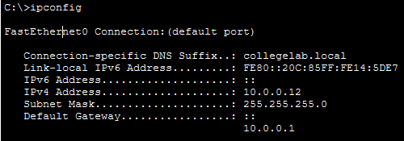

Router - DHCP Bindings (WORKING COMMAND):
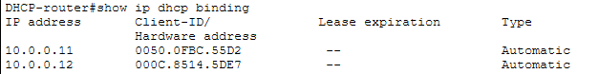

Router - DHCP Pool Status (WORKING COMMAND):
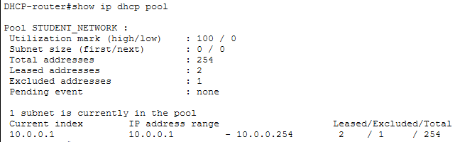

`

PAYAL AMALE S.I.W.S. College Major practical 03

18001
Router - Interface Status:
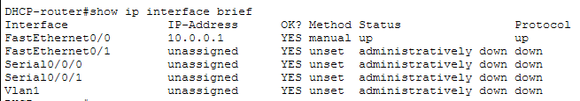

Connectivity Test - PC0 to Router:
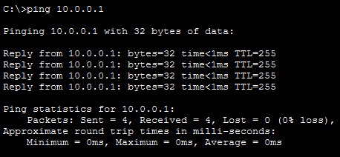

Conclusion: The DHCP server has been successfully configured on the router using commands compatible with Cisco Packet Tracer.

Q2.Demonstrate DNS Server in Packet Tracer.

Aim:- To configure a DNS server to resolve domain names to IP addresses and test name resolution in the network.

Devices Needed:
- 1 Server (DNS Server)
- 1 Router
- 1 Switch

PAYAL AMALE S.I.W.S. College Major practical 03

18001
- 2 PCs (Clients)

TOPOLOGY:-
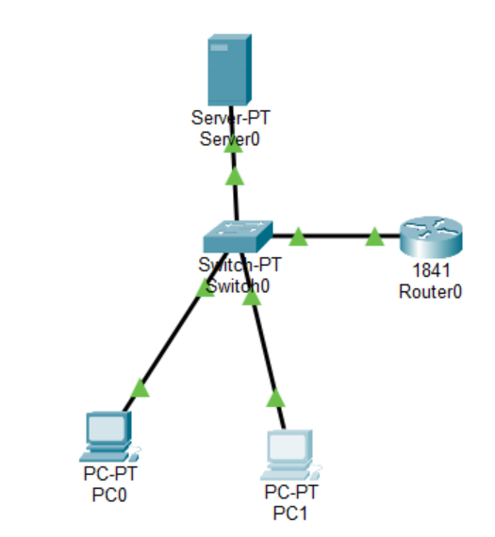

Code:
Configure DNS Records:
Name: www.company.com
Type: A Record
Address: 192.168.1.5 # Points to Server itself
-> Add

Name: ftp.company.com
Type: A Record
Address: 192.168.1.5 # Points to Server itself
-> Add

Name: mail.company.com
Type: A Record
Address: 192.168.1.5 # Points to Server itself
-> Add

PAYAL AMALE S.I.W.S. College Major practical 03

18001 Server IP Configuration:
- IP Address: 192.168.1.5
- Subnet Mask: 255.255.255.0
- Default Gateway: 192.168.1.1
- DNS Server: 192.168.1.5
Router Configuration:
Router>enable
Router#configure terminal
Router(config)#interface FastEthernet0/0
Router(config-if)#ip address 192.168.1.1 255.255.255.0
Router(config-if)#no shutdown
Router(config-if)#exit
Router(config)#exit
Router#copy running-config startup-config

PC0 Configuration:
- IP Address: 192.168.1.10
- Subnet Mask: 255.255.255.0
- Default Gateway: 192.168.1.1
- DNS Server: 192.168.1.5

PC1 Configuration:
- IP Address: 192.168.1.11
- Subnet Mask: 255.255.255.0
- Default Gateway: 192.168.1.1
- DNS Server: 192.168.1.5

In PC Command Prompt
PC0:
C:\>nslookup www.company.com
C:\>nslookup ftp.company.com
C:\>nslookup mail.company.com
C:\>ping www.company.com
C:\>ping ftp.company.com

PAYAL AMALE S.I.W.S. College Major practical 03

18001
PC1:
C:\>nslookup www.company.com
C:\>nslookup mail.company.com
C:\>ping www.company.com
C:\>ping mail.company.com

Output:
PC0 nslookup Results:
C:\>nslookup www.company.com
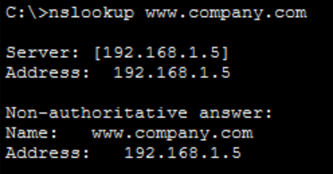

C:\>nslookup ftp.company.com
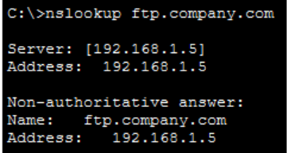

C:\>nslookup mail.company.com
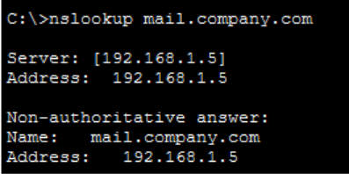

PAYAL AMALE S.I.W.S. College Major practical 03

18001

PC0 Ping Results:
C:\>ping www.company.com
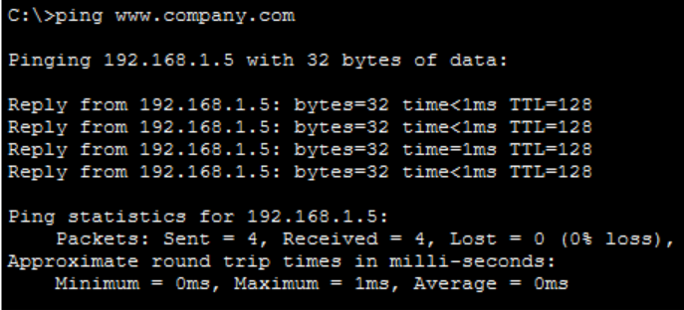

PC1 nslookup Results:
C:\>nslookup mail.company.com
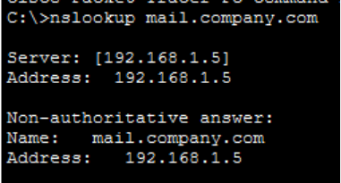

C:\>nslookup www.company.com
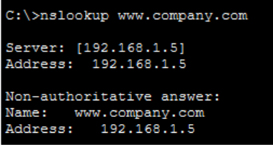

PAYAL AMALE S.I.W.S. College Major practical 03

18001

PC2 Ping Results:
C:\>ping mail.company.com
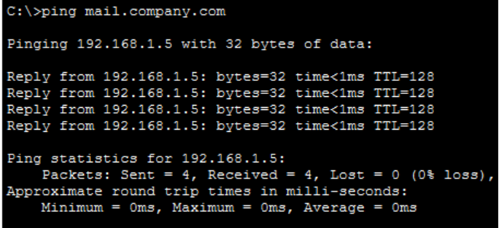

Conclusion: The DNS server has been configured successfully.

Q3. Demonstrate FTP Server in Packet Tracer.

Aim: To configure an FTP server and test file transfer between server and clients in the network.

Devices Needed:
- 1 Server (FTP Server)
- 1 Switch
- 2 PCs (FTP Clients)

Connection :
- Connect all devices to the switch using copper straight-through cables

PAYAL AMALE S.I.W.S. College Major practical 03

18001

Topology:
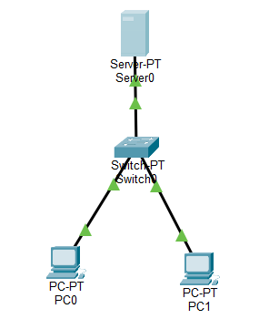

Code:
Server Configuration (FTP):
- Click on Server → Services tab → FTP
- FTP Server Settings:
- FTP Service: ON
- Add User Account:
- Username: admin
- Password: cisco
- Check all permissions: Read/Write/List/Delete/Rename
- Click Add

Server IP Configuration:
- IP Address: 192.168.1.5
- Subnet Mask: 255.255.255.0
- Default Gateway: 192.168.1.1

PAYAL AMALE S.I.W.S. College Major practical 03

18001

PC1 Configuration:
- IP Address: 192.168.1.10
- Subnet Mask: 255.255.255.0
- Default Gateway: 192.168.1.1

PC2 Configuration:
- IP Address: 192.168.1.11
- Subnet Mask: 255.255.255.0
- Default Gateway: 192.168.1.1

Create Test File on PC1
- Click on PC1 → Desktop tab → Text Editor
- Type: This is a test file for FTP transfer
- Save as: upload_test.txt

Verification: In PC Command Prompt
PC1 FTP Commands:
C:\>ftp 192.168.1.5
Username: admin
Password: cisco
ftp> dir
ftp> put upload_test.txt
ftp> dir
ftp> get welcome.txt
ftp> delete notes.txt
ftp> quit

PC2 FTP Commands:
C:\>ftp 192.168.1.5
Username: admin
Password: cisco
ftp> dir
ftp> get upload_test.txt
ftp> rename upload_test.txt downloaded_file.txt
ftp> dir
ftp> quit
PAYAL AMALE S.I.W.S. College Major practical 03

18001
Ping Test (Both PCs):
C:\>ping 192.168.1.5
Output:
PC1 FTP Session:
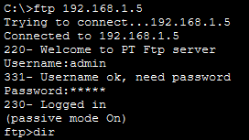

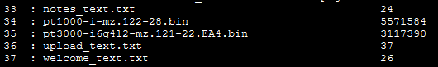

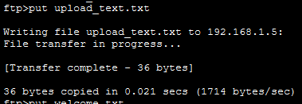

PAYAL AMALE S.I.W.S. College Major practical 03

18001

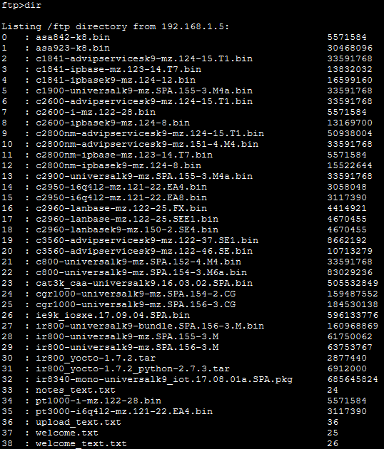

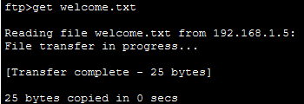

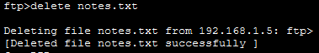

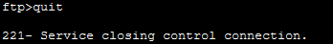

PAYAL AMALE S.I.W.S. College Major practical 03

18001
Ping Test Results:
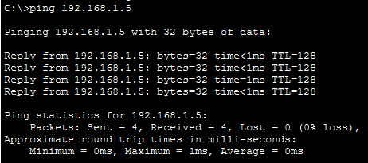

PC2 FTP Session:
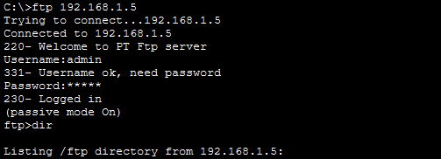

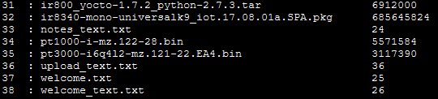

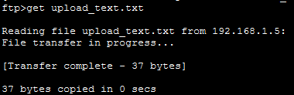

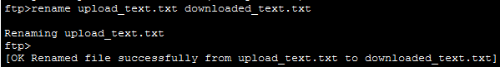

PAYAL AMALE S.I.W.S. College Major practical 03

18001

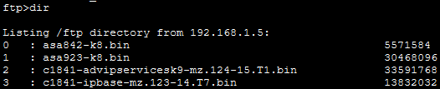

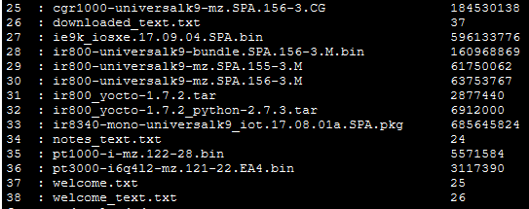

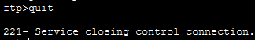

Ping Test Results:
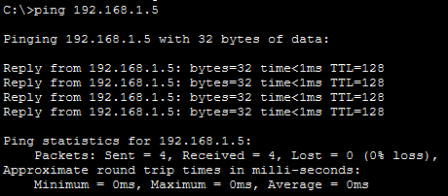

Conclusion: The FTP server has been configured successfully.

PAYAL AMALE S.I.W.S. College Major practical 03

18001
Q4. Demonstrate HTTP Server in Packet Tracer.

Aim: To configure a web server and test web page access from clients using web browsers.

Steps:
- In packet tracer place 1 Server-PT and 2 PC-PT and 1 Switch.
- Connect Server-PT with Switch via FastEthernet0 using straight-through copper cord.
- Connect PC-PT0 and PC-PT1 with Switch via FastEthernet0 using straight-through copper cords.
- Set the IP address of Server-PT and both PCs in IP configuration.
- Configure HTTP service on Server-PT and create web pages.
- Test web access from both PCs.

Topology:
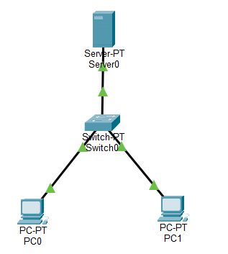

Code:
Server-PT Configuration:
- IP Address: 192.168.1.10
- Subnet Mask: 255.255.255.0
- Default Gateway: 192.168.1.1

PAYAL AMALE S.I.W.S. College Major practical 03

18001
HTTP Service Configuration:
- HTTP Service: ON
- Created web pages: index.html, about.html, courses.html

Web Page Code:
index.html:
html
<!DOCTYPE html>
<html>
<head>
<title>My College Website</title>
</head>
<body>
<h1>Welcome to College Server</h1>
<p>This website is hosted on Server-PT in Packet Tracer.</p>
<a href="about.html">About College</a> |
<a href="courses.html">Courses</a>
</body>
</html>

about.html:
html
<!DOCTYPE html>
<html>
<head>
<title>About Our College</title>
</head>
<body>
<h1>About Our Institution</h1>
<p>Established in 1990, we provide quality technical education.</p>
<p><b>Departments:</b> Computer, IT, Electronics, Mechanical</p>
<a href="index.html">Home</a> |
<a href="courses.html">Our Courses</a>
</body>
</html>

PAYAL AMALE S.I.W.S. College Major practical 03

18001
courses.html:
html
<!DOCTYPE html>
<html>
<head>
<title>College Courses</title>
</head>
<body>
<h1>Available Courses</h1>
<ul>
<li>Computer Engineering</li>
<li>Information Technology</li>
<li>Electronics & Telecommunication</li>
<li>Mechanical Engineering</li>
</ul>
<a href="index.html">Home</a> |
<a href="about.html">About College</a>
</body>
</html>

PC-PT0 Configuration:
- IP Address: 192.168.1.20
- Subnet Mask: 255.255.255.0
- Default Gateway: 192.168.1.1

PC-PT1 Configuration:
- IP Address: 192.168.1.30
- Subnet Mask: 255.255.255.0
- Default Gateway: 192.168.1.1

Verification: In Both PCs Web Browser
PC-PT0:
- Open Web Browser
- Enter URL: http://192.168.1.10
- Enter URL: http://192.168.1.10/about.html
- Enter URL: http://192.168.1.10/courses.html

PAYAL AMALE S.I.W.S. College Major practical 03

18001
PC-PT1:
- Open Web Browser
- Enter URL: http://192.168.1.10
- Enter URL: http://192.168.1.10/about.html
- Enter URL: http://192.168.1.10/courses.html

Connectivity Test:
C:\>ping 192.168.1.10
Output:
Ping Test Results:
Pc0 :
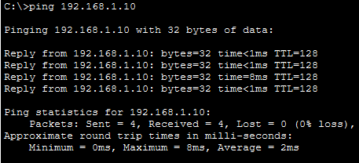

Pc1 :
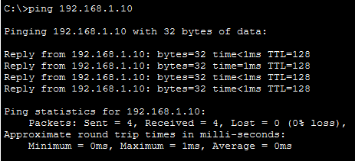

PAYAL AMALE S.I.W.S. College Major practical 03

18001
Web Browser Output:
Homepage (http://192.168.1.10) :
Pc0 :
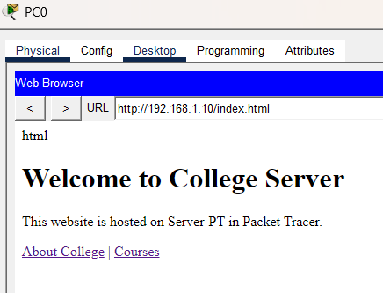

Pc1 :
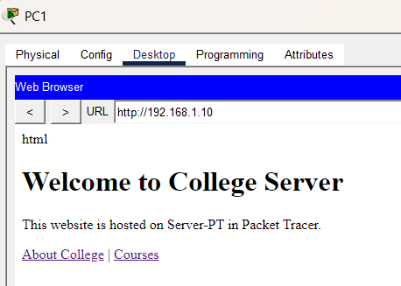

PAYAL AMALE S.I.W.S. College Major practical 03

18001
About Page (http://192.168.1.10/about.html):
Pc0 :
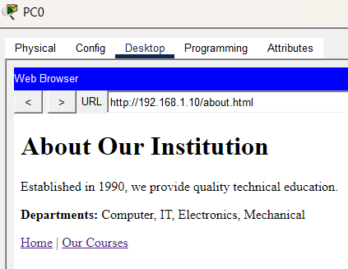

Pc1 :
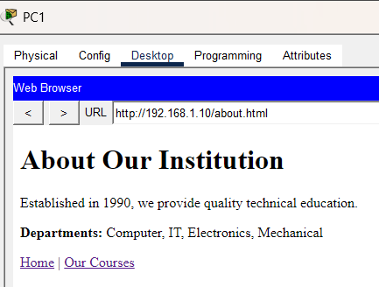

PAYAL AMALE S.I.W.S. College Major practical 03

18001
Courses Page (http://192.168.1.10/courses.html):
Pc0 :
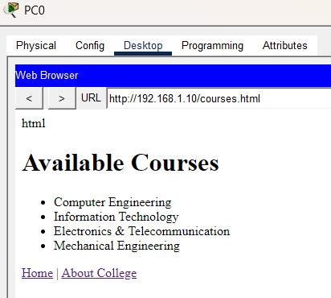

Pc1 :
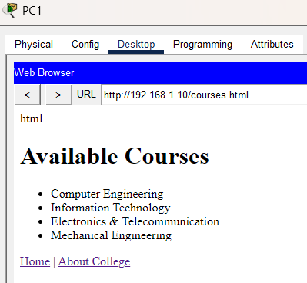

Conclusion: The HTTP web server has been configured successfully on Server-PT.

PAYAL AMALE S.I.W.S. College Major practical 03

18001
Q5. Demonstrate Telnet in Packet Tracer.

Aim: To configure Telnet on routers to enable remote administration and test remote connectivity between devices.

Devices Needed:
- 2 Routers
- 1 Switch
- 2 PCs (Telnet Clients)

Connection Guide:
- Connect Router0 and Router1 via serial cable (Serial DCE)
- Connect Router0 to Switch via FastEthernet
- Connect PCs to Switch via copper straight-through cables

Topology:
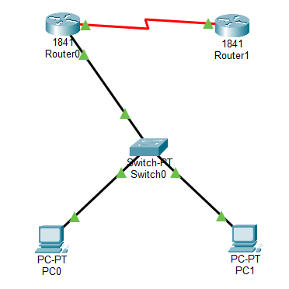

Code:
Router1 Configuration:
Router>enable
Router#configure terminal
Router(config)#hostname Router0
Router0(config)#interface FastEthernet0/0
Router0(config-if)#ip address 192.168.1.1 255.255.255.0

PAYAL AMALE S.I.W.S. College Major practical 03

18001
Router0(config-if)#no shutdown
Router0(config-if)#exit
Router0(config)#interface Serial0/0/0
Router0(config-if)#ip address 10.0.0.1 255.255.255.252
Router0(config-if)#clock rate 64000
Router0(config-if)#no shutdown
Router0(config-if)#exit
Router0(config)#line vty 0 4
Router0(config-line)#password cisco
Router0(config-line)#login
Router0(config-line)#exit
Router0(config)#enable secret class
Router0(config)#ip route 0.0.0.0 0.0.0.0 10.0.0.2
Router0(config)#exit
Router0#copy running-config startup-config

Router2 Configuration:
Router>enable
Router#configure terminal
Router(config)#hostname Router1
Router1(config)#interface Serial0/0/0
Router1(config-if)#ip address 10.0.0.2 255.255.255.252
Router1(config-if)#no shutdown
Router1(config-if)#exit
Router1(config)#interface FastEthernet0/0
Router1(config-if)#ip address 172.16.1.1 255.255.255.0
Router1(config-if)#no shutdown
Router1(config-if)#exit
Router1(config)#line vty 0 4
Router1(config-line)#password cisco
Router1(config-line)#login
Router1(config-line)#exit
Router1(config)#enable secret class
Router1(config)#ip route 192.168.1.0 255.255.255.0 10.0.0.1

PAYAL AMALE S.I.W.S. College Major practical 03

18001

Router1(config)#exit
Router1#copy running-config startup-config

PC1 Configuration:
- IP Address: 192.168.1.10
- Subnet Mask: 255.255.255.0
- Default Gateway: 192.168.1.1

PC2 Configuration:
- IP Address: 192.168.1.11
- Subnet Mask: 255.255.255.0
- Default Gateway: 192.168.1.1

Verification: In PC Command Prompt
PC1 Telnet Tests:
C:\>ping 192.168.1.1
C:\>ping 10.0.0.2
C:\>ping 172.16.1.1
C:\>telnet 192.168.1.1
C:\>telnet 10.0.0.2

PC2 Telnet Tests:
C:\>ping 192.168.1.1
C:\>ping 10.0.0.2
C:\>ping 172.16.1.1
C:\>telnet 192.168.1.1
C:\>telnet 172.16.1.1

Router Verification Commands:
Router#show users
Router#show line vty 0
Router#show running-config | include vty

PAYAL AMALE S.I.W.S. College Major practical 03

18001
Output:
PC1 Telnet to Router1:
telnet 192.168.1.1
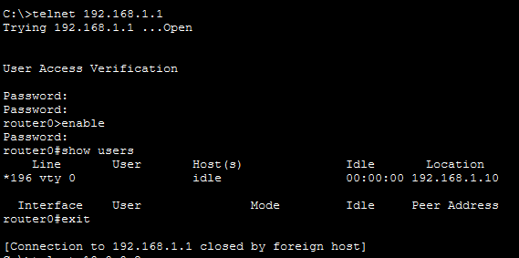

PC1 Telnet to Router2:
C:\>telnet 10.0.0.2
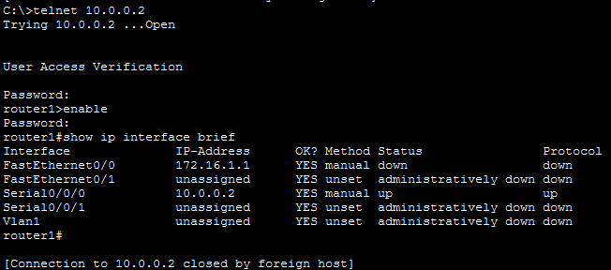

PAYAL AMALE S.I.W.S. College Major practical 03

18001
PC2 Telnet to Router1:
C:\>telnet 192.168.1.1
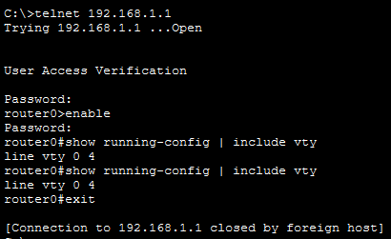

Ping Test Results:
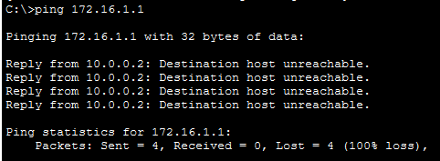

Router Show Users Output:
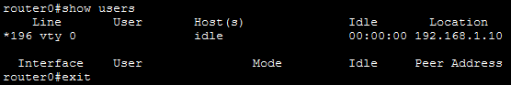

Conclusion: Telnet has been configured successfully on both routers.

PAYAL AMALE S.I.W.S. College Major practical 03

18001

PRACTICAL NO 04

STUDY OF CRYPTOGRAPHY SUBSTITUTION TECHNIQUES

AIM :- To study and Implement Substitution Techniques in a Cryptography using python to perform Encryption & Description of a message.

PRORAM :-

def encrypt(text, shift):
result = ""
for char in text:
if char.isalpha():
base = 'A' if char.isupper() else 'a'
result += chr((ord(char) - ord(base) + shift) % 26 + ord(base))
else:
result += char
return result

def decrypt(text, shift):
return encrypt(text, -shift)

text = input("Enter plain text: ")
shift = int(input("Enter shift value: "))

encrypted_text = encrypt(text, shift)
print("Encrypted Text:", encrypted_text)

decrypted_text = decrypt(encrypted_text, shift)
print("Decrypted Text:", decrypted_text)

PAYAL AMALE S.I.W.S. College Major practical 04
18001

OUTPUT :-

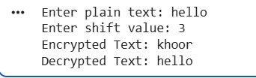

CONCLUSION :-

The substitution technique replaces each letter in the plaintext with another letter based on a fixed shift value.
Through this practical, we learned how Caesar Cipher works and how basic encryption and decryption are implemented in Python.

PAYAL AMALE S.I.W.S. College Major practical 04

18001
PRACTICAL NO 05
STUDY OF SYMMETRIC KEY - DES & AES

AIM :- To Study and Implement Symmetric Key Cryptography using DES & AES Algorithm in Python.

ALORITHM OF (DES) :-

1. Import DES module.
2. Create a secret key and pad the message to match the block size.
3. Encrypt the plain text.
4. Decrypt the cipher-text.
5. Display the results.

PROGRAM :-

!pip install pycryptodome
from Crypto.Cipher import DES
from Crypto.Util.Padding import pad, unpad
key = b'12345678'
cipher = DES.new(key, DES.MODE_ECB)
plaintext = input("Enter message: ")
padded_text = pad(plaintext.encode(), DES.block_size)
encrypted_text = cipher.encrypt(padded_text)
print("Encrypted Text:", encrypted_text)
decrypted_text = unpad(cipher.decrypt(encrypted_text), DES.block_size)
print("Decrypted Text:", decrypted_text.decode())

PAYAL AMALE S.I.W.S. College Major practical 05

18001

OUTPUT :-

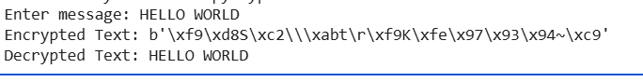

ALORITHM OF (AES) :-

1. Import AES module.
2. Create a 16-byte secret key and pad the message.
3. Encrypt and then decrypt using AES.
4. Display the output.

PROGRAM :-

from Crypto.Cipher import AES
from Crypto.Util.Padding import pad, unpad

key = b'thisismysecretky'
cipher = AES.new(key, AES.MODE_ECB)

plaintext = input("Enter message: ")

padded_text = pad(plaintext.encode(), AES.block_size)
encrypted_text = cipher.encrypt(padded_text)
print("Encrypted Text:", encrypted_text)
decrypted_text = unpad(cipher.decrypt(encrypted_text), AES.block_size)
print("Decrypted Text:", decrypted_text.decode())

PAYAL AMALE S.I.W.S. College Major practical 05

18001

OUTPUT :-

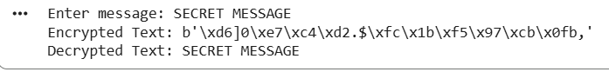

CONCLUSION :-

In symmetric key cryptography, the same key is used for both encryption and decryption. DES and AES are two important symmetric algorithms, with AES being more secure and faster due to its larger key size and modern design.

PAYAL AMALE S.I.W.S. College Major practical 05

18001
PRACTICAL NO 06

STUDY OF ASYMETRIC KEY (DH & RSA)

AIM :- To Study and Implement Asymmetric Key Cryptography using DH & RSA Algorithms in Python.

ALORITHM OF DH :-

1. Select a large prime number P and a primitive root G.
2. Each user selects a private key (random number).
Let user A choose private key a.
Let user B choose private key b.
3. Compute the public key:
A = G^a mod P
B = G^b mod P
4. Exchange public keys between both users.
5. Compute the shared secret key:
Key₁ = B^a mod P
Key₂ = A^b mod P
6. Both keys will be identical.

PROGRAM :-

P = 23 # prime number
G = 9 # primitive root
a = 4 # Alice's private key
b = 3 # Bob's private key
A = (G ** a) % P
B = (G ** b) % P
key1 = (B ** a) % P # Alice's key
key2 = (A ** b) % P # Bob's key

PAYAL AMALE S.I.W.S. College Major practical 06

` 18001

print("Publicly Shared Values:")
print("P:", P, "G:", G)
print("Public Key of Alice (A):", A)
print("Public Key of Bob (B):", B)
print("\nSecret Keys:")
print("Alice's Secret Key:", key1)
print("Bob's Secret Key:", key2)

OUTPUT :-

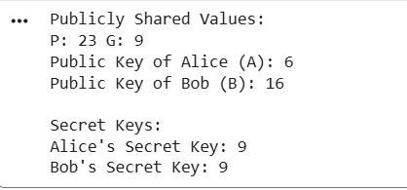

ALORITHM OF RSA :-

1. Choose two prime numbers p and q.
2. Compute n = p × q.
3. Compute Euler’s totient function
φ(n) = (p − 1) × (q − 1).
4. Choose public key e such that
1 < e < φ(n) and gcd(e, φ(n)) = 1.
5. Compute private key d such that
(d × e) mod φ(n) = 1.
6. For encryption:
C = (M^e) mod n.
7. For decryption:
M = (C^d) mod n.

PAYAL AMALE S.I.W.S. College Major practical 06

18001

PROGRAM :-

def gcd(a, b):
while b != 0:
a, b = b, a % b
return a

p = 7
q = 17
n = p * q
phi = (p - 1) * (q - 1)

e = 5
while gcd(e, phi) != 1:
e += 1

d = pow(e, -1, phi)

print("Public Key (e, n):", (e, n))
print("Private Key (d, n):", (d, n))

msg = int(input("Enter message (as number): "))
cipher = pow(msg, e, n)
print("Encrypted Message:", cipher)

decrypted = pow(cipher, d, n)
print("Decrypted Message:", decrypted)

PAYAL AMALE S.I.W.S. College Major practical 06

18001

OUTPUT :-

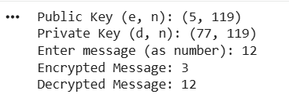

CONCLUSION :-

Asymmetric cryptography uses two different keys for secure communication. In this practical DH was used to generate secret keys, and RSA was used for message encryption and decryption, demonstrating secure data exchange.

PAYAL AMALE S.I.W.S. College Major practical 06

18001
PRACTICAL NO 07

STUDY OF MD5 ALGORITHM

AIM :- To study and implement the MD5 (Message Digest 5) hashing algorithm using Python.

ALGORITHM OF MD5 :-

1. Import the hash-lib library.
2. Accept a message from the user.
3. Encode the message to bytes.
4. Use hash-lib.md5() to compute the hash.
5. Display the hexadecimal digest.

PROGRAM :-

import hashlib
text = input("Enter text to hash: ")
md5_hash = hashlib.md5(text.encode())
print("MD5 Hash Value:", md5_hash.hexdigest())

OUTPUT :-

CONCLUSION :-

MD5 is a simple and efficient hashing technique that converts input data into a fixed-length digest.
It ensures data integrity by verifying whether data has been altered during transmission or storage.

PAYAL AMALE S.I.W.S. College Major practical 07

18001
PRACTICAL NO 08
STUDY OF HASH FUNCTION

AIM :- To study and implement the RSHash (Robert Sedgwicks Hash) function using Python.

PROGRAM :-

def RSHash(string):
a = 63689
b = 378551
hash_val = 0
for ch in string:
hash_val = hash_val * a + ord(ch)
a = a * b
return hash_val % (2**32) # limit hash to 32 bits
text = input("Enter any text: ")
print("RSHash Value:", RSHash(text))

OUTPUT :-

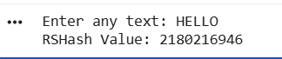

CONCLUSION :-

RSHash is a simple and efficient hash function that generates a fixed-size numerical value for any input string.It is widely used for data lookup, hashing, and indexing, though it is not suitable for secure cryptographic applications.

PAYAL AMALE S.I.W.S. College Major practical 08
18001
PRACTICAL NO 09
TO CREATE, EXPORT AND VALIDATE A DIGITAL CERTIFICATE.

AIM :- To write a code to Create, Export and Validate a digital Certificate.

ALGORITHM :- 1. Download and Install opensol.
2. Add its bin path in environmental variable .
3. Open command prompt.

PROGRAM :- C:\User\Payal\Desktop>openssl req -x509 -days 365 -newkey rsa:2048 -keyout private-key.pem -out certificate.pem
Enter PEM Pass: 123456
​​Country Name (2 letter code) []: IN
​State or Province Name (full name) []: Maharashtra
​Locality Name []: Mumbai
​Organization Name []: SIWS
​Organizational Unit Name []: IT
​Common Name []: TMD
​Email Address []: amalepayal044@gmail.com
C:\User\Payal\Desktop> openssl pkcs12 -export -in certificate.pem -inkey private-key.pem -out TMD.pfx
Enter Export Password: 123456
​Verifying - Enter Export Password: 123456
C:\User\Payal\Desktop> openssl pkcs12 -in TMD.pfx -clcerts -nokeys -out public-key.pem
Enter Import Password: 123456
Import the certificate

PAYAL AMALE S.I.W.S. College Major practical 09

18001

OUTPUT :-

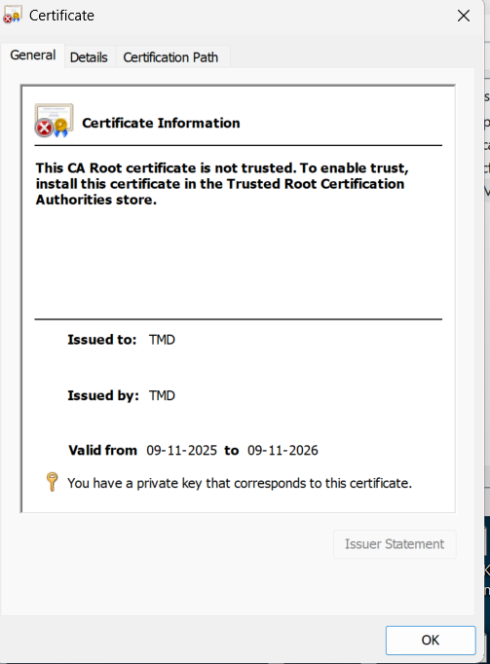

CONCLUSION :- The above creation is done.

PAYAL AMALE S.I.W.S. College Major practical 09

